Biology 313
Discussion for week of 10-23, 2017
16 points

2. Botulinium toxin is one of the most deadly toxins known- it comes from Clostridium bacteria that grow in anaerobic conditions (like improperly canned food). There are several types of botulinium toxins, designated types A-G. All of them prevent binding of the vesicle to the terminal membrane, by cleaving spsecific proteins.
a. (2pts) Name 2 proteins the toxin could possibly act on

Synaptotagmin - Ca++ dependent step. Binds 5 Ca++ ions, senses Ca++ levels and promotes vesicle docking. it inhibits some molecular clamp on the SNARE complex (t-snares + v-snares) allowing it to form - or allowing T-SNARES to interact with v-SNARES

Synaptobrerin(VAMP) – Snare protein

b. (2pt) In poultry, there is a condition called “limber neck”: where the bird can’t hold up its head, and the neck just flops around. They get this by eating food that is in anerobic conditions. How would this result from botulinium toxin?

The toxin would prevent n.t. from being received in postsynaptic neurons, preventing an AP from being transmitted. This can prevent certain motor functions from working properly, and can prevent muscle contraction.

c. (2pt) in humans, tiny bits of botulinium toxin are injected under the skin to make people look younger. Why would this toxin erase wrinkles?

This toxin can prevent muscle contraction in facial tissue. Less movement can result in fewer wrinkles.

3. Huntington's disease is caused by a mutation in the gene encoding the Huntingtin protein. Huntingtin is normally associated with the motor proteins in axons. Its mutation is believed to severely disrupt both retrograde and anterograde axoplasmic transport.
a). (2pts) What would be some effects of such a mutation on neuronal function? If the effect is permanent, what would you expect to happen to the neuron?

Axoplasmic transport is responsible for movement of mitochondria, lipids, synaptic vesicles, proteins, and organelles to and from a neuron's cell body, through the cytoplasm of its axon. This allows for items synthesized in the cell body to make it to the end of the axon for use. It is also responsible for is also responsible for moving molecules destined for degradation from the axon back to the cell body, where they are broken down. Disruption of these pathways might cause several issues such as inability to remove unwanted toxins back to lysosomes for proper disposal or inability to bring peptide based nt from the cell body down the axon for transmission. I would expect that over a long period of time this would cause neurons to die or release less nt per AP.

b. (2pt) The local anesthetic lidocaine stops the movement of kinesin. How might this affect the function of a neuron?

Kinesin is used during fast axoplasmic transport from cell body to terminal (anterograde). This could prevent manufactured nt or other materials from reaching the terminal in a timely matter, preventing the neuron from functioning properly.

4. (6 pts) Cockroaches are, as you may know, very good at scurrying away when approached. They can detect movements of potential predators (or swatters) using a set of hairs located on their cerci, which are peg-like projections off the posterior end of their abdomen. As you can see in the photo below, there are different thicknesses and lengths of the cerci. Some are more sensitive to air currents than others. Suppose you were to use this to design a circuit that when a specific pair of hairs (let’s call them the A hairs) were moved, they would reliably cause the cockroach’s leg muscle to contract so the animal can initiate a run. In contrast, other hairs may cause the muscle to contract as well (let’s call them the B hairs), but their input is initiated in less urgent situations, and so it would take a large number of them stimulated at the same time to get the muscle to contract.
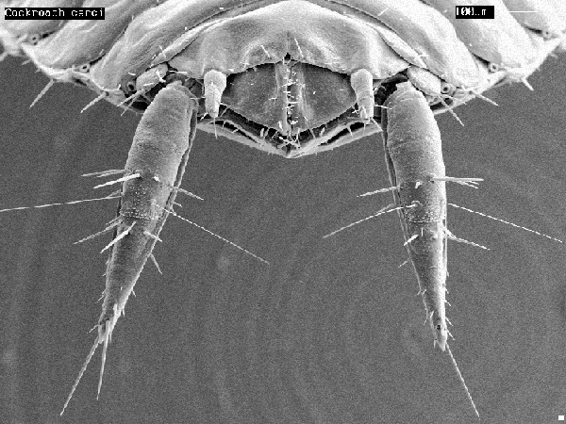
What are TWO DIFFERENT ways that you could design a circuit so that the A hairs’ input is more likely activate the leg escape circuit than the B hairs are? To keep it simple, we will hypothesize that the A hair and the B hairs all synapse with one neuron, the Escape neuron, and this is the neuron whose activity causes the escape behavior. (a well labeled drawing may be a good way to present your answer)

For A hairs, we can have many more presynaptic neurons/ sensory neurons that synapse with the single escape neuron. Alternatively, we can increase Ca++ levels around the sensory neurons from the A hair, so that AP’s would release more NT. However, utilizing multiple sensory neurons to have a higher spacial/temporal summation would make A hairs more sensitive. To have B hairs be less sensitive, have fewer sensory neurons synapse with the escape neuron or a lower Ca++ concentration.

